**Data Mining**

**Concept Quiz**

**Oct 11**

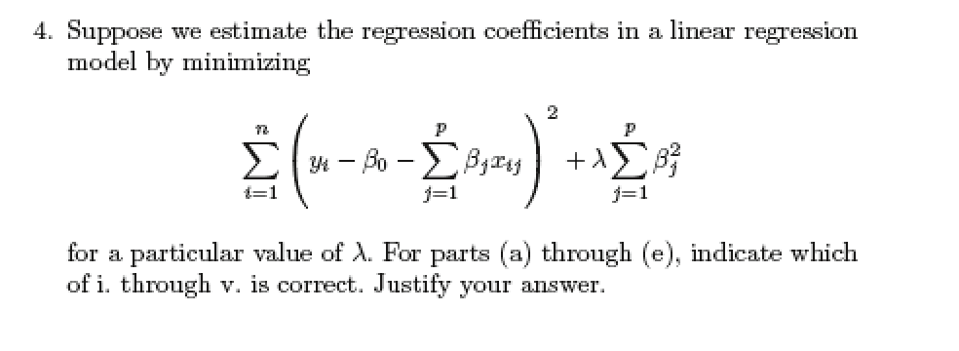

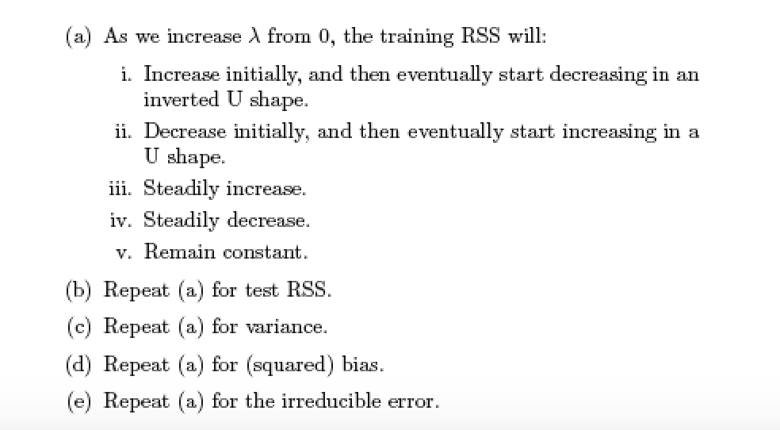

**a)**

**Will steadily increase(iii).**

**An increase in lamda will cause increasing restrictions to beta, causing the model to become less flexible. This will lead to increased RSS.**

**b)**

**It will decrease initially then will slowly transform into a U shape (ii).**

**While the model is become less and less flexible, the RSS will decrease first and start increasing when overfitting occurs.**

**c)**

**It will steadily decrease(iv), as model flexibility decrease variance will decrease.**

**d)**

**It will steadily increase(iii). Bias will increase with as model flexibility decrease.**

**e)**

**It will remain constant(v).**

**Irreducible error is independent of model parameter and therefore independent of lamda.**